**Batch: A1 Roll No.: 1911004**

**Experiment / assignment / tutorial No. 1**

|  |
| --- |
| **TITLE:** Requirement **S**pecification Document for Mini Project |

**AIM:** To learn and understand the way of analysing the gathered information in the previous phase for the development process and prepare requirement specification documents. Concept of software engineering. **______________________________________________________________________**

**Expected Course outcome of Experiment:**

Process of gathering requirements and converting them into specifications.

Document created will be used by both, the customer and the developer, to understand WHAT is going to be developed.

**_____________________________________________________________________**

**Books/ Journals/ Websites referred:**

1. Roger Pressman, Software Engineering: A practitioner's Approach, McGraw Hill, 2010 ,6th edition

2. Ian Somerville, Software Engineering , Addison Wesley,2011,9th edition

1. http://en.wikipedia.org/wiki/Software_requirements_specification

**_____________________________________________________________________**

**Pre Lab/ Prior Concepts:**

**Requirements analysis** in systems engineering and software engineering encompasses those tasks that go into determining the needs or conditions to meet for a new or altered product, taking account of the possibly conflicting requirements of the various stakeholders, such as beneficiaries or users. It is an early stage in the more general activity of requirements engineering which encompasses all activities concerned with eliciting, analyzing, documenting, validating, and managing software or system requirements.

Requirements analysis is critical to the success of a systems or software project. The requirements should be documented, actionable, measurable, testable, traceable, related to identified business needs or opportunities, and defined to a level of detail sufficient for system design.

Conceptually, requirements analysis includes three types of activities:

* **Eliciting requirements**: the task of identifying the various types of requirements from various sources including project documentation, (e.g. the project charter or definition), business process documentation, and stakeholder interviews. This is sometimes also called requirements gathering.
* **Analyzing requirements**: determining whether the stated requirements are clear, complete, consistent, and unambiguous, and resolving any apparent conflicts.
* Recording requirements: Requirements may be documented in various forms, usually including a summary list, and may include natural-language documents, use cases, or process specifications.

New systems change the environment and relationships between people, so it is important to identify all the stakeholders, taking into account all their needs, and ensure they understand the implications of the new systems. Analysts can employ several techniques to elicit the requirements from the customer. These may include the development of scenarios, the identification of use cases, the use of workplace observation or ethnography, holding interviews, or focus groups (more aptly named in this context as requirements workshops, or requirements review sessions), and creating requirements lists. Prototyping may be used to develop an example system that can be demonstrated to stakeholders. Where necessary, the analyst will employ a combination of these methods to establish the exact requirements of the stakeholders, so that a system that meets the business needs is produced

Different types of Requirements

* Functional requirements
* Usability requirements
* Reliability requirements
* Performance requirements
* Security requirements

**Software Requirements Specification for:**

**E-learning website**

**Version 1.0**

**Prepared by Nidhi Bhanushali**

**K.J. Somaiya College of Engineering**

**25/08/2021**

**Table of Contents**

**Table of Contents**

**1. Introduction** 5

1.1 Purpose 5

1.2 Product Scope 5

1.3 References 5

**2. Overall Description** 5

2.1 Product Perspective 5

2.2 Product Functions 6

2.3 User Classes and Characteristics **Error! Bookmark not defined.**

2.4 Operating Environment 7

2.5 Design and Implementation Constraints 7

2.6 User Documentation 7

2.7 Assumptions and Dependencies **Error! Bookmark not defined.**

**3. External Interface Requirements** 8

3.1 User Interfaces 8

3.2 Hardware Interfaces 8

3.3 Software Interfaces 8

3.4 Communications Interfaces **Error! Bookmark not defined.**

**4. System Features Error! Bookmark not defined.**

4.1 System Feature 1 8

4.2 System Feature 2 9

**5. Other Nonfunctional Requirements** 10

5.1 Performance Requirements 10

5.2 Safety Requirements **Error! Bookmark not defined.**

5.3 Security Requirements **Error! Bookmark not defined.**

5.4 Software Quality Attributes **Error! Bookmark not defined.**

5.5 Business Rules **Error! Bookmark not defined.**

**6. Other Requirements Error! Bookmark not defined.**

**Appendix A: Glossary** 11

**Appendix B: Analysis Models** 13

**Appendix C: To Be Determined List Error! Bookmark not defined.**

**Introduction**

**Purpose**

This project focuses on developing an E-learning website that provides facility to institute and students in a manner that the learning, evaluation; assessment do not remain limited to the four walls of a classroom. This website works by finding new ways to make an institute a center of excellence in education by providing all the study material, exams available to students online. The students belonging to different places, unable to attend regular classes get access to educational courses across a wide range of programs. It provides a facility for students to communicate with faculty regarding academics

**Product Scope**

This will mainly be used by distance education programs offered by institutes, in order to enable students to get the academic facilities from any computer connected to the Internet. This website will be designed in a way that it can be easily extended to provide more features and will be easily customizable so that it can work according to every potential user.

**References**

1)Ieee -E-learning: Research and applications **April 2002**

[Industrial and Commercial Training](https://www.researchgate.net/journal/Industrial-and-Commercial-Training-0019-7858) 34(2):44-53

DOI:[10.1108/00197850210417528](http://dx.doi.org/10.1108/00197850210417528)

**2)** [**https://www.researchgate.net/publication/305686215_Research_paper_on_E-Learning_application_design_features_Using_cloud_computing_software_engineering_approach**](https://www.researchgate.net/publication/305686215_Research_paper_on_E-Learning_application_design_features_Using_cloud_computing_software_engineering_approach)

**Overall Description**

**Product Perspective**

The product idea is taken from popular websites such as w3schools, ted-ed, khan academy, aiming to create an e-learning website to make an institute a center of excellence in education by providing all the study material, exams available to students online. This is the same idea that we have used in our project.

**Product Functions**

The system will have 4 roles - Faculty, Student, Supporting Faculty and Administrator. There will be a set of permissions associated with each role.

* Faculty:- This role enables the user to offer courses, upload lectures, set exams for courses he is offering.
* Student:-This role enables the user to register for courses, answer tests, view lectures.
* Administrator:- This role enables the user to manage users (create, edit and delete) besides performing other administrative tasks such as monitoring the system operation, editing system configuration, etc.
* Supporting staff member:- This role enable the supporting staff member to upload the lecture recorded by the faculty and in a way assist the faculty in there work
* It will store all data in a single centralized database. The database will contain the following information:

1. Student details

2. Faculty members details

3. Students query and their solutions

4. Courses Information

* The site will provide course study material to the students in electronic form.
* All the information including course details, fee structure, and notices for students will also be displayed on the site.
* The site will be used by three different types of users: Students, Faculties, and administrators having a different interface for each type of user.
* Each user will be provided with a username and password to access his/her account on the site.
* The students can take the mock test of their course and evaluate themselves.
* The faculties can upload lectures on the site.

**Operating Environment**

* PCs running Windows operating system
* Macs running OS X Panther (v10.3)
* iPads running iPadOS 13.0 or later.
* Android-based Tablets running on (v4.2) jelly bean

The application will be available as a web application that can be accessed from anywhere via the web browser.

**Design and Implementation Constraints**

* The proposed web application will be implemented with Java for front-end design purposes & For the database purpose, we can opt for JavaDB/Oracle.

* Since this is a Web-based application, it should work on major browsers like Internet Explorer, Mozilla Firefox, Google Chrome, Opera, etc.

* Since the application is intended for the authenticated users only, an anonymous person should not be able to access and operate over the user data.
* Only Web browser support for Firefox, Google Chrome, Safari, Microsoft Edge

**User Documentation**

* User guide video.
* User manual pdf.
* Online email helpdesk.

**Assumptions and Dependencies**

* The Users of the platform are teachers and students that belong to colleges
* The technological command of the users is adept enough to understand the simple interface of the website for practical use
* A stable Internet connection is expected of the user
* User has the operating system at the appropriate version or above as listed
* User has a web browser installed on a website

**External Interface Requirements**

**User Interfaces**

Since this is a Web-based application it should provide a very User-friendly interface. It should be easy to navigate. A decent and pleasant appearance with ease of navigation should help users.

**Hardware Interfaces**

The hardware requirement at the user end is really simple and the website can also run on the hardware that can run a basic simple browser, although the hardware should be good enough during peak times for the web servers.

**Software Interfaces**

The application should support all major web browsers that will make it convenient for the user to access our system with ease. The back- end i.e. the database services will be used to a great extent and hence it has to be efficiently designed.

**Communications Interfaces**

HTTP protocol will be used for data transfer and communication therefore a web browser and internet connection will be required. FTP protocol will be used for downloading study material from the website.

**System Features**

**System Feature 1**

*<Don’t really say “System Feature 1.” State the feature name in just a few words.>*

4.1.1 Description and Priority

*<Provide a short description of the feature and indicate whether it is of High, Medium, or Low priority. You could also include specific priority component ratings, such as benefit, penalty, cost, and risk (each rated on a relative scale from a low of 1 to a high of 9).>*

4.1.2 Stimulus/Response Sequences

*<List the sequences of user actions and system responses that stimulate the behavior defined for this feature. These will correspond to the dialog elements associated with use cases.>*

4.1.3 Functional Requirements

The features of the e-learning site will be:

1. It will store all data in a single centralized database. The database will contain the following information:

* Student details
* Faculty members details
* Students query and their solutions
* Courses Information

1. The site will provide course study material to the students in electronic form.
2. All the information including course details, fee structure and notices for students will also be displayed on the site.
3. The site will be used by four different types of users: Students, Faculties, supporting staff and the administrators having different interfaces for each type of user.
4. Admin changes the classroom according to the academic year plan.
5. Faculty can give editing rights to supporting faculty.
6. Each user will be provided with a username and password to access his/her account on the site.
7. The students can take their mock test of their course and evaluate themselves.
8. The faculties supporting faculties can upload lectures on the site.
9. Students can give their attendance which can be used supporting faculty.

**System Feature 2**

**Other Nonfunctional Requirements**

**Performance Requirements**

The application should be able to operate on all major web-browsers with all of its fundamental functions . It should not slow-down the system even at peak hours without affecting the quality of service of the system.

**Safety Requirements.**

Since, application is intended for the authenticated users only, an anonymous person should not be able to access and operate over the user data. So to ensure the safety of the user data adequate security shall be provided to the database so that the user data remains safe.

**Security Requirements**

The server on which the E-learning web application will have its own security to prevent unauthorized write/delete access.

The system should provide a secure login to the users by using advanced secure login algorithms and provide access only to the authorized users as security is the key requirement of this system.

The user ID and the password should not be shared with anyone (students/faculty/or anyone else).

**Software Quality Attributes**

The testing of the complete workflow of the app application consists of:

* Registering the user
* Login and Signup options
* Updating the database
* Allow the students to view the lectures with necessary login
* Allowing the faculties to upload the lecture and notes.

Some other functionalities which can be tested:

* **Testing for Mobile Responsiveness**
* The responsive design must be tested to be sure that it works on multiple screen sizes.
* **Checking Compatibility with Android/IOS versions**
* Different Android/IOS versions must be tested so that the app performs well on older versions too.

The server will have sufficient ram to handle the crowd on the website. A centralized database will be used so that the data can be accessed from anywhere through the internet.

**Business Rules**

Registration of both students as well as teachers must be under strict supervision, any discrepancy will not be resolved by developers of the system. This system will be completely free to install on teachers phone and student's phones there will not be any charges. And all the rights to modify any data will go only through the admin.

The content of the website will be protected under the copyright act so that no person from the institute or outside will have the right to upload or use the content on any other platform.

**Other Requirements**

All the requirements have been mentioned above.

**Appendix A: Glossary**

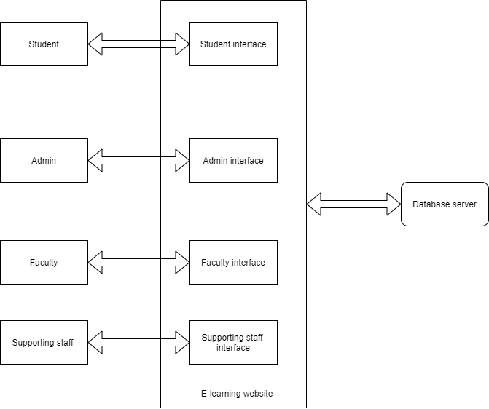**Supporting staff is a member who will assist the senior faculties in doing there work and finally uploading the material and videos on the website. The student only from the college will have the access to the content. The members will be able to login only using the college email id.**

**Appendix B: Analysis Models**

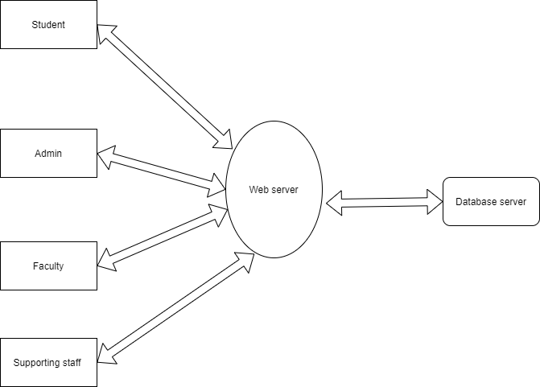

***Student functionalities.***

**Personal Information**-This enables the student to view and modify the user’s personal information.

**Access Course Material-** This enables the student to see lectures and download the study materials of the course.

**Post Queries**- This will enable the student to send queries to their faculties and view answers to their queries.

**Send Feedback**- This will enable the students to provide the feedback to the admin. **Change Password**- This enable the students to change the password for their account. **Taking Exam**- This enable the students to take the online automated exams on the courses they are enrolled in.

***Faculty functionalities.***

**Personal Information**-This enables the student to view and modify the user’s personal information.

**Uploading Course Material**- This enables the faculty to upload the lectures and study materials.

**Answer Queries**- This will enable the faculties to view queries of the students and post answers for the same.

**Change Password**- This enable the faculties to change the password for their account. Creating Exams- This enables the faculty to create an exam for the course. He will have to provide the questions and their answers , time and other details.

***Admin functionalities.***

**Course Management**- This enables an administrator to add,delete, modify course information, such course name, duration, fee, and other details.

**Student Management**- This enables an administrator to add, delete and block the student accounts.

**Faculty Management**- This enables an administrator to add, delete and block the faculty accounts.

**View Feedback**- This enables an administrator to view the feedback received from the students and faculties.

**Post Notice**- This enables an administrator to display notices and other messages on the website.

**Search Information**- This enables an administrator to access all the information about all the users of the system.

***Supporting staff functionalities.***

**Personal Information**-This enables the memberto view and modify the user’s personal information.

**Uploading Course Material**- This enables the faculty to upload the lectures and study materials.

**Change Password**- This enable the faculties to change the password for their account. Creating Exams- This enables the faculty to create an exam for the course. He will have to provide the questions and their answers , time and other details.

**Post Laboratory Activity:**

**Complete the following activity**

**Virtual Lab Link:** [**http://vlabs.iitkgp.ernet.in/se/1/exercise/**](http://vlabs.iitkgp.ernet.in/se/1/exercise/)

Exercise1:

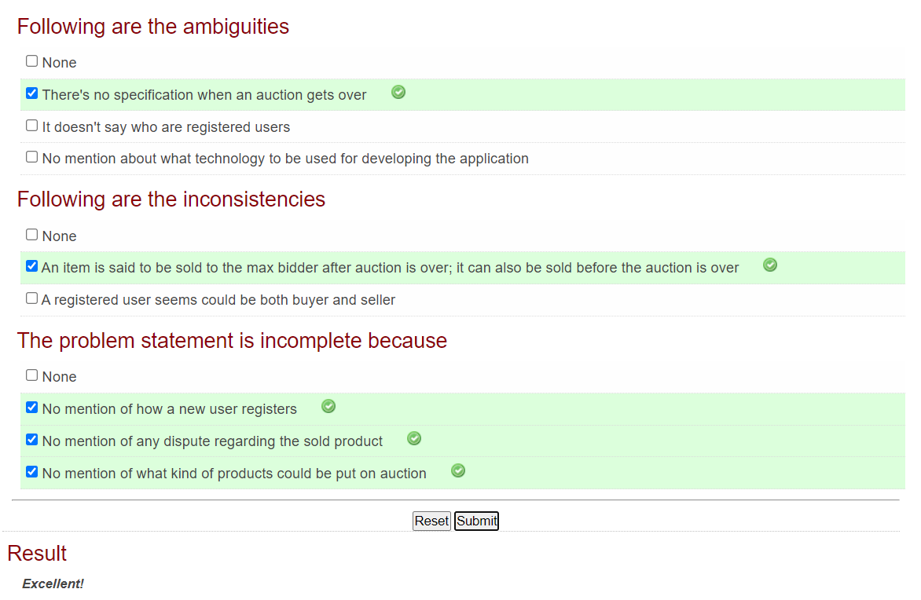

Exercise2:

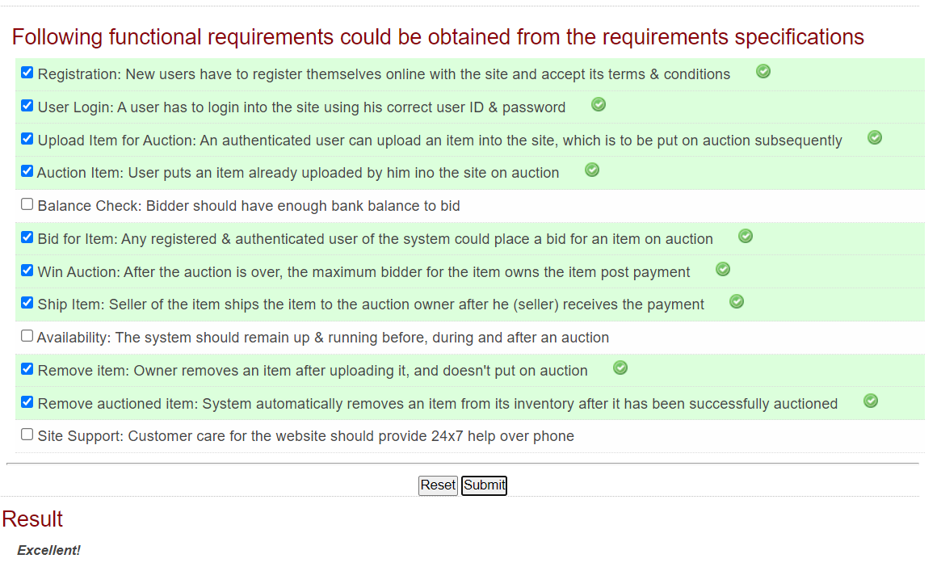

Exercise3:

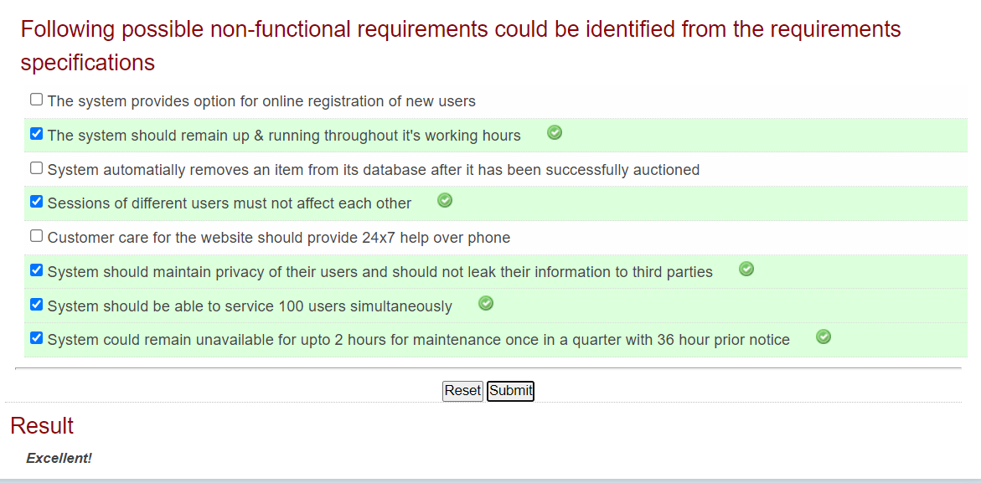

Self evaluation:

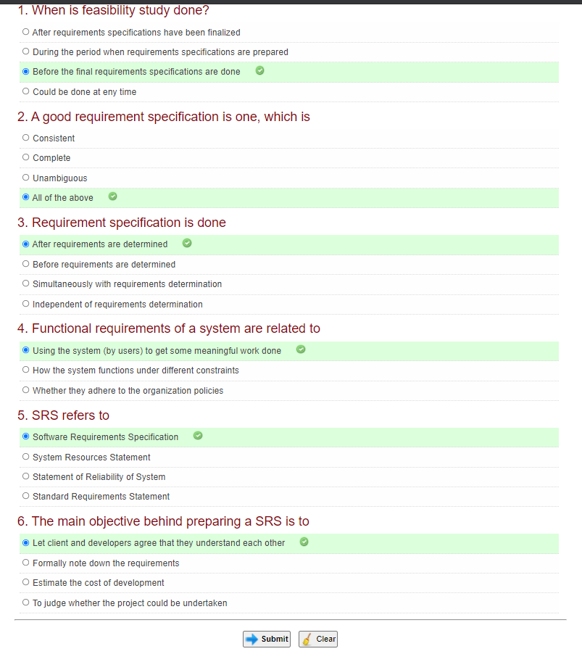

*Please ensure you are submitting the document on our LMS. Append the document in this and submit the same after answering Post Lab Descriptive Questions.*

**Post Lab Descriptive Questions:**

* 1. What are different techniques to gather information for software development?

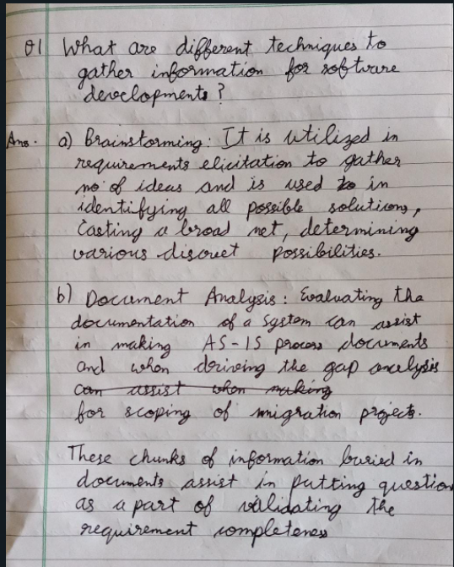

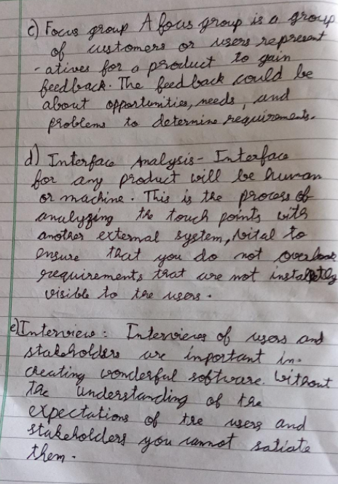

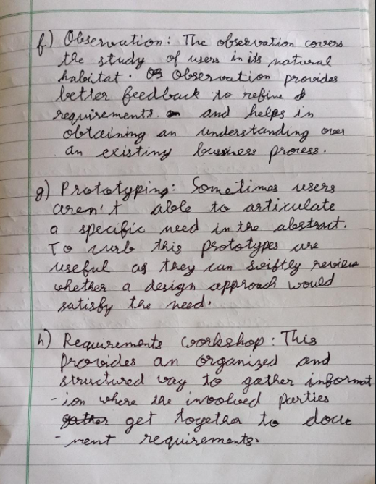

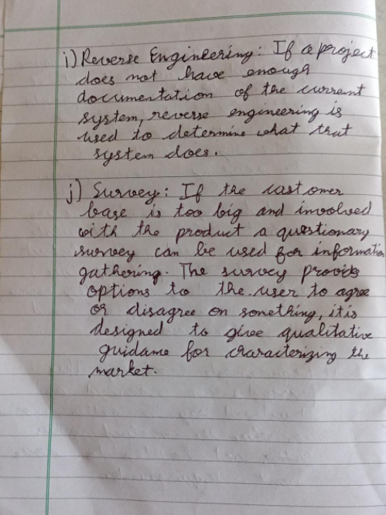

* 1. List verification and validation techniques for requirements.

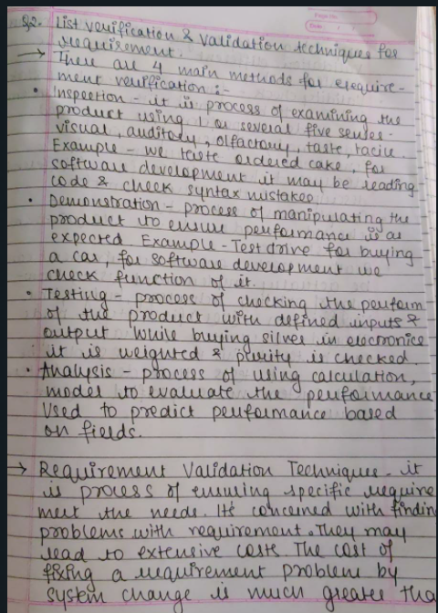

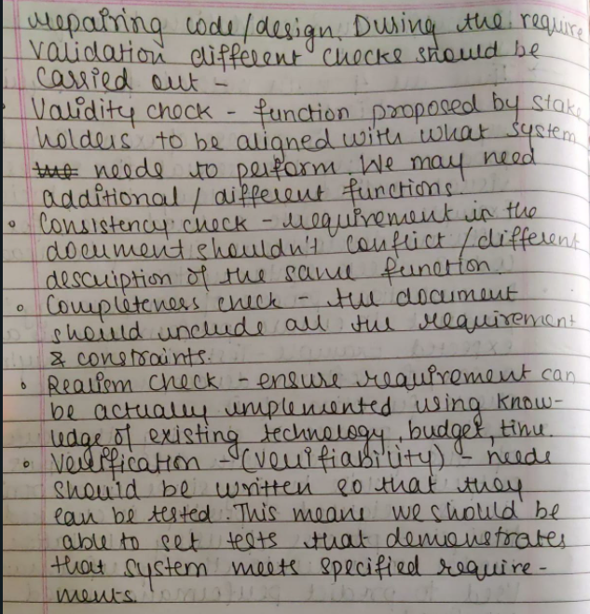

* 1. Prepare a questionnaire for the allotted project considering your lab instructor is the client for requirement gathering.

